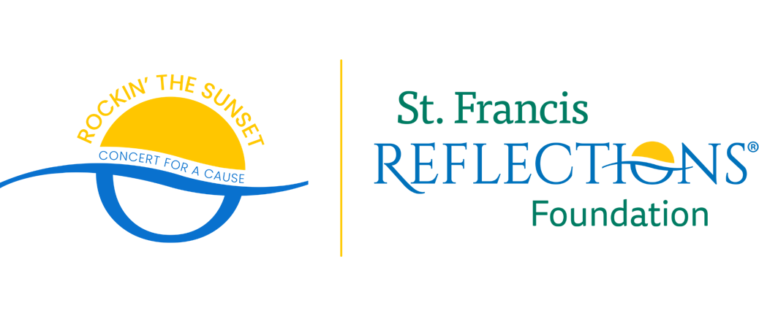

FOR IMMEDIATE RELEASE

Chassity Inglis
info@chassityinglis.com
321-123-4567

St. Francis Reflections Foundation to Host Second Annual “Rockin’ The Sunset – Concert For A Cause” Featuring Elton John Tribute Band

Concert Will Raise Funds For St. Francis Reflections Foundations

Titusville, Florida – St. Francis Reflections Foundation will host its second annual “Rockin’ The Sunset – Concert For A Cause” featuring Elton John tribute band, Greggie And The Jets on Friday, April 21 at Space Coast Stadium in Viera, Florida.

Greggie And The Jets will take you on a tour through the decades of Elton John’s greatest hits. Concert goers are encouraged to attend in their best, Elton John inspired outfits for the Rockin’ The Sunset costume contest. It will be a fun night to remember for the whole family and supports a great cause.

All proceeds will go to benefit St. Francis Reflections Lifestage Care programs including NorthStar – Child Grief and We Honor Veterans.

###

St. Francis Reflections Foundation raises funds and cultivates community partnerships to support the various services provided by St. Francis Reflections. Learn more by visiting www.reflectionslsc.org/about/foundation or like their Facebook page at www.facebook.com/StFrancisReflectionsFoundation.

